Issue Period: 1/11/25-4/11/25
- Google Profile Picture would inconsistently fail to render on the website, leading to a un-aesthetically pleasing UI with a missing image box.
- Solution: Adding referrerPolicy="no-referrer" - also need stable internet connection
Finding picture was difficult but example would take on this shape:

Where the frame’s insides would match the toolbar colouring.
- It now correctly looks consistently as so:
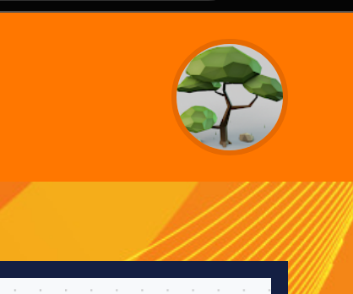
Depending on profile picture.

Issue Period: 27/10/25~
- Login button and register buttons were both set-up on frontend from initial sprint (not active at the time. However these were set-up to go to the same route with Auth0 as it is one domain for the log-in/register options and as such two buttons turned out to not be necessary (bugged with two different buttons with two names leading to the same location)
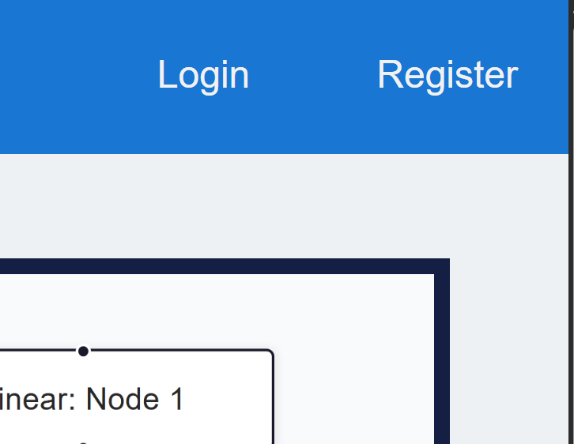
- Solution: Remove register button and place the logic in the auth0 route to choose if a registration is necessary, and not two buttons which perform the same action.
